

A PROJECT REPORT

ON

MINI-Project

SUBMITTED BY

● Aman Kumar (201500073)

● Subrat Jain (201500711)

● Divyansh Bhargava (201500231)

●Shyam Ji Gupta (201500687)

● Harshit Singh (201500286)

Department of Computer Engineering & Applications **Institute of Engineering & Technology GLA University**

**Mathura-281406**

**Declaration**

We hereby declare that the work in the project report entitled "**Mario Jumping Game**" GLA University Mathura for the award of degree of **"B.Tech CS"** is an authentic record of my work carried out during the Fifth semester Third year, 2022 under the supervision of **Mr. Vikas** **Kumar.** The matter embodied in this project report has not been submitted elsewhere by anybody for the award of any other degree/diploma.

|  |  |  |
| --- | --- | --- |
| **S.NO** | **NAME** | **UNIVERSITY ROLLNO** |
| 1 | Aman Kumar | 201500073 |
| 2 | Subrat Jain | 201500711 |
| 3 | Divyansh Bhargava | 201500231 |
| 4 | Shyam Ji Gupta | 201500687 |
| 5 | Harshit Singh | 201500286 |

**CERTIFICATE**

This is to certify that the project entitled "**Mario Jumping game**" has been developed by **B.Tech CS** students of **GLA University Mathura** towards partial fulfillment of the requirements for the award of the degree of Bachelor of Computer Science is a genuine record of the work carried out by Him/her under My Supervision and Guidance and the project report is the original work of student. She/he has worked on the project “**MARIO JUMPING GAME”**. She/he has used **CSS, HTML, JAVASCRIPT** for the project. His/her work is satisfactory. I wish him/her all the best for his bright future***.***

**Date:19/10/2022** **Signature of Guide**

Place: Mathura Mr. Vikas Kumar

**Acknowledgement**

The beatitude, bliss & euphoria that accompany the successful completion of any task would be incomplete without the expression of the appreciation of simple virtues to the people who made it possible. So ,with reverence, veneration and honors. We acknowledge all those whose guidance and encouragement has made successful in winding up this.

We owe a huge debt of thanks too many people without whom none of this would have been possible. We are thankful to Mr. Vikas Kumar (Project Guide) for valuable suggestions and enthusiastic interest during the entire session.

Finally, we are very much grateful to the Institute and all the Faculty members, without their personal attention and time to time help and care, it would not have been possible for us to complete this report.

We perceive as this opportunity as a big milestone in my career development. I will strive to use gained skills and knowledge in the best possible way, and I will continue to work on their improvement, in order to attain desired career objectives. Hope to continue cooperation with all of you in the future.

Index

TITLE Page No.

1. INTRODUCTION 6
   1. **Project Overview**  6
   2. **Project Description** 6
2. TECHNOLOGIES USED 7
   1. **HTML**  1
   2. **CSS** 1
   3. **JAVASCRIPT** 10

1. SOURCE CODE 15
2. PREVIEWS 36
3. CONCLUSION 44
4. REFRENCES 45

**INTRODUCTION**

**1.1. Project Overview**

**“MARIO JUMPING GAME”** as the name suggested that this website provide the opportunity to the user by provide them resources about play games online without download only by using internet. No extra space/memory required.

**1.2. Project Description**

**“MARIO JUMPING GAME”** is the website which provide all resources of the game. If somebody feels bored ,he/she can play the game by using only internet. There is no need to download and install it. Just play and enjoy it.

**Technologies Used:**

**HTML:**

HTML is an acronym which stands for **Hyper Text Markup Language** which is used for creating web pages and web applications. Let's see what is meant by Hypertext Markup Language, and Web page.

**Hyper Text:** HyperText simply means "Text within Text." A text has a link within it, is a hypertext. Whenever you click on a link which brings you to a new webpage, you have clicked on a hypertext. HyperText is a way to link two or more web pages (HTML documents) with each other.

**Markup language:** A markup language is a computer language that is used to apply layout and formatting conventions to a text document. Markup language makes text more interactive and dynamic. It can turn text into images, tables, links, etc.

**Web Page:** A web page is a document which is commonly written in HTML and translated by a web browser. A web page can be identified by entering an URL. A Web page can be of the static or dynamic type. **With the help of HTML only, we can create static web pages**.

## **Description of HTML Example**

**<!DOCTYPE>:** It defines the document type or it instruct the browser about the version of HTML.

**<html >** :This tag informs the browser that it is an HTML document. Text between html tag describes the web document. It is a container for all other elements of HTML except <!DOCTYPE>

**<head>:** It should be the first element inside the <html> element, which contains the metadata(information about the document). It must be closed before the body tag opens.

**<title>:** As its name suggested, it is used to add title of that HTML page which appears at the top of the browser window. It must be placed inside the head tag and should close immediately. (Optional)

**<body>**: Text between body tag describes the body content of the page that is visible to the end user. This tag contains the main content of the HTML document.

**<h1>** : Text between <h1> tag describes the first level heading of the webpage.

## **Brief History of HTML**

In the late 1980's , a physicist, Tim Berners-Lee who was a contractor at CERN, proposed a system for CERN researchers. In 1989, he wrote a memo proposing an internet based hypertext system.

**Tim Berners-Lee** is known as the father of HTML. The first available description of HTML was a document called "HTML Tags" proposed by Tim in late 1991. The latest version of HTML is HTML5, which we will learn later in this tutorial.

## **HTML Versions**

Since the time HTML was invented there are lots of HTML versions in market, the brief introduction about the HTML version is given below:

**HTML 1.0:** The first version of HTML was 1.0, which was the barebones version of HTML language, and it was released in1991.

**HTML 2.0:** This was the next version which was released in 1995, and it was standard language version for website design. HTML 2.0 was able to support extra features such as form-based file upload, form elements such as text box, option button, etc.

**HTML 3.2:** HTML 3.2 version was published by W3C in early 1997. This version was capable of creating tables and providing support for extra options for form elements. It can also support a web page with complex mathematical equations. It became an official standard for any browser till January 1997. Today it is practically supported by most of the browsers.

**HTML 4.01:** HTML 4.01 version was released on December 1999, and it is a very stable version of HTML language. This version is the current official standard, and it provides added support for stylesheets (CSS) and scripting ability for various multimedia elements.

**HTML5 :** HTML5 is the newest version of HyperText Markup language. The first draft of this version was announced in January 2008. There are two major organizations one is W3C (World Wide Web Consortium), and another one is WHATWG( Web Hypertext Application Technology Working Group) which are involved in the development of HTML 5 version, and still, it is under development.

## **Features of HTML**

1) It is a very **easy and simple language**. It can be easily understood and modified.

2) It is very easy to make an **effective presentation** with HTML because it has a lot of formatting tags.

3) It is a **markup language**, so it provides a flexible way to design web pages along with the text.

4) It facilitates programmers to add a **link** on the web pages (by html anchor tag), so it enhances the interest of browsing of the user.

5) It is **platform-independent** because it can be displayed on any platform like Windows, Linux, and Macintosh, etc.

6) It facilitates the programmer to add **Graphics, Videos, and Sound** to the web pages which makes it more attractive and interactive.

7) HTML is a case-insensitive language, which means we can use tags either in lower-case or upper-case

**CSS:**

CSS stands for Cascading Style Sheets. It is a style sheet language which is used to describe the look and formatting of a document written in markup language. It provides an additional feature to HTML. It is generally used with HTML to change the style of web pages and user interfaces. It can also be used with any kind of XML documents including plain XML, SVG and XUL.

CSS is used along with HTML and JavaScript in most websites to create user interfaces for web applications and user interfaces for many mobile applications.

## **What does CSS do**

* You can add new looks to your old HTML documents.
* You can completely change the look of your website with only a few changes in CSS code.

## **Why use CSS**

These are the three major benefits of CSS:

## **1) Solves a big problem**

Before CSS, tags like font, color, background style, element alignments, border and size had to be repeated on every web page. This was a very long process. For example: If you are developing a large website where fonts and color information are added on every single page, it will be become a long and expensive process. CSS was created to solve this problem. It was a W3C recommendation.

## **2) Saves a lot of time**

CSS style definitions are saved in external CSS files so it is possible to change the entire website by changing just one file.

## **3) Provide more attributes**

CSS provides more detailed attributes than plain HTML to define the look and feel of the website.

**JAVASCRIPT:**

## **What is JavaScript**

JavaScript (js) is a light-weight object-oriented programming language which is used by several websites for scripting the webpages. It is an interpreted, full-fledged programming language that enables dynamic interactivity on websites when applied to an HTML document. It was introduced in the year 1995 for adding programs to the webpages in the Netscape Navigator browser. Since then, it has been adopted by all other graphical web browsers. With JavaScript, users can build modern web applications to interact directly without reloading the page every time. The traditional website uses js to provide several forms of interactivity and simplicity.

Although, JavaScript has no connectivity with Java programming language. The name was suggested and provided in the times when Java was gaining popularity in the market. In addition to web browsers, databases such as CouchDB and MongoDB uses JavaScript as their scripting and query language.

## **Features of JavaScript**

There are following features of JavaScript:

1. All popular web browsers support JavaScript as they provide built-in execution environments.
2. JavaScript follows the syntax and structure of the C programming language. Thus, it is a structured programming language.
3. JavaScript is a weakly typed language, where certain types are implicitly cast (depending on the operation).
4. JavaScript is an object-oriented programming language that uses prototypes rather than using classes for inheritance.
5. It is a light-weighted and interpreted language.
6. It is a case-sensitive language.
7. JavaScript is supportable in several operating systems including, Windows, macOS, etc.
8. It provides good control to the users over the web browsers.

## **History of JavaScript**

In 1993, **Mosaic**, the first popular web browser, came into existence. In the **year 1994**, **Netscape** was founded by **Marc Andreessen**. He realized that the web needed to become more dynamic. Thus, a 'glue language' was believed to be provided to HTML to make web designing easy for designers and part-time programmers. Consequently, in 1995, the company recruited **Brendan Eich** intending to implement and embed Scheme programming language to the browser. But, before Brendan could start, the company merged with **Sun Microsystems** for adding Java into its Navigator so that it could compete with Microsoft over the web technologies and platforms. Now, two languages were there: Java and the scripting language. Further, Netscape decided to give a similar name to the scripting language as Java's. It led to 'Javascript'. Finally, in May 1995, Marc Andreessen coined the first code of Javascript named '**Mocha**'. Later, the marketing team replaced the name with '**LiveScript**'. But, due to trademark reasons and certain other reasons, in December 1995, the language was finally renamed to 'JavaScript'. From then, JavaScript came into existence.

## **Application of JavaScript**

JavaScript is used to create interactive websites. It is mainly used for:

* Client-side validation,
* Dynamic drop-down menus,
* Displaying date and time,
* Displaying pop-up windows and dialog boxes (like an alert dialog box, confirm dialog box and prompt dialog box),
* Displaying clocks etc.

**Javascript library**

javaScript libraries and frameworks make website and application development easier with wide-ranging features and functionalities — all thanks to [JavaScript’s dynamic, flexible, and engaging features](https://kinsta.com/blog/scripting-languages/#1-javascriptecmascript). According to a [StackOverflow survey from 2020](https://insights.stackoverflow.com/survey/2020" \t "_blank), JavaScript continues to be the [most commonly used programming language](https://kinsta.com/blog/best-programming-language-to-learn/#javascript) (for the 8th year), with **67.7%** of the respondents using it.

Its versatility favors both back-end and front-end development, in addition to testing them. As a result, you can find many JavaScript libraries and frameworks that serve various purposes. Hence, it can be confusing to developers when choosing the right fit for their project.

## What Are JavaScript Libraries?

JavaScript libraries contain various functions, methods, or objects to perform practical tasks on a webpage or JS-based application. You can even [build a WordPress site](https://kinsta.com/blog/gatsby-wordpress/) with them.

Think of them as a book library where you revisit to read your favorite books. You may be an author and enjoy other authors’ books, get a new perspective or idea, and utilize the same in your life.

Similarly, a JavaScript library has codes or functions that developers can reuse and repurpose. A developer writes these codes, and other developers reuse the same code to perform a certain task, like preparing a slideshow, instead of writing it from scratch. It saves them significant time and effort.

They are precisely the motive behind creating JavaScript libraries, which is why you can find dozens of them for multiple use cases. They not only save you time but also bring simplicity to the entire development process.

**The best JavaScript animation libraries**

* Anime.js.
* Velocity. js.
* Theatre. js.
* Popmotion.
* Three. js.
* GreenSock JS.
* AniJS.
* Mo. Js

SOURCES CODE:

<!DOCTYPE html>

<html>

  <head>

  <script src="lib/p5.js"></script>

  <script src="lib/p5.dom.min.js"></script>

  <script src="lib/p5.sound.min.js"></script>

  <script src="lib/p5.play.js"></script>

  <link rel="stylesheet" type="text/css" href="style.css">

  <meta charset="utf-8">

   <style>

    body{

      background-image: radial-gradient(red,green,blue);

    }

    a{

      color: crimson;

      font-size: x-large;

    }0

   </style>

</head>

<body>

    <script src="sketch.js"></script>

    <H1> MARIO JUMPING GAME</H1>

    </body>

</html>

html,

body {

  margin: 0;

  padding: 0;

  box-sizing: border-box;

}

canvas {

  display: block;

  margin: auto;

}

var bg, bgImage;

var mario, mario\_running;

var mario\_collided;

var brickGroup, brickImage;

var coinImage, coinsGroup;

var coinScore = 0;

var mushObstacleImage, turtleObstacleImage, obstaclesGroup;

var gameState = "PLAY";

var restartImg;

function preload() {

  bgImage = loadImage("images/bg12.jpg");

  mario\_running = loadAnimation(

    "images/mar1.png",

    "images/mar2.png",

    "images/mar3.png",

    "images/mar4.png",

    "images/mar5.png",

    "images/mar6.png",

    "images/mar7.png"

  );

  brickImage = loadImage("images/brick.png");

  coinImage = loadAnimation(

    "images/con1.png",

    "images/con2.png",

    "images/con3.png",

    "images/con4.png",

    "images/con5.png"

  );

  // Add Sounds

  coinSound = loadSound("sounds/coinSound.mp3");

  jumpSound = loadSound("sounds/jump.mp3");

  mushObstacleImage = loadAnimation(

    "images/mush1.png",

    "images/mush2.png",

    "images/mush3.png",

    "images/mush4.png",

    "images/mush5.png",

    "images/mush6.png"

  );

  turtleObstacleImage = loadAnimation(

    "images/tur1.png",

    "images/tur2.png",

    "images/tur3.png",

    "images/tur4.png",

    "images/tur5.png"

  );

  mario\_collided = loadAnimation("images/dead.png");

  dieSound = loadSound("sounds/dieSound.mp3");

  restartImg = loadImage("images/restart.png");

}

function setup() {

  createCanvas(1000, 600);

  bg = createSprite(600, 300);

  bg.addImage(bgImage);

  bg.scale = 0.5;

  mario = createSprite(200, 520, 20, 50);

  mario.addAnimation("running", mario\_running);

  mario.scale = 0.2;

  ground = createSprite(200, 580, 400, 10);

  brickGroup = new Group();

  coinsGroup = new Group();

  obstaclesGroup = new Group();

  mario.addAnimation("collided", mario\_collided);

  restart = createSprite(500, 300);

  restart.addImage(restartImg);

  restart.visible = false;

}

function draw() {

  drawSprites();

  if (gameState == "PLAY") {

    // Make background Move

    bg.velocityX = -5;

    if (bg.x < 100) {

      bg.x = bg.width / 4;

    }

    // Make Mario Jump-Up

    if (keyDown("space")) {

      mario.velocityY = -10;

      // Mario Jump Sound

      jumpSound.play();

    }

    // Make Mario Come-Down

    mario.velocityY = mario.velocityY + 0.5;

    // Ground for Mario

    mario.collide(ground);

    ground.visible = false;

    generateBricks();

    // Stay on Bricks

    for (var i = 0; i < brickGroup.length; i++) {

      var temp = brickGroup.get(i);

      if (temp.isTouching(mario)) {

        mario.collide(temp);

      }

    }

    // Mario Issue

    if (mario.x < 200) mario.x = 200;

    if (mario.y < 50) mario.y = 50;

    generateCoins();

    // Collect Coins

    for (var i = 0; i < coinsGroup.length; i++) {

      var temp = coinsGroup.get(i);

      if (temp.isTouching(mario)) {

        coinScore++;

        //Coin Sound

        coinSound.play();

        temp.destroy();

        temp = null;

      }

    }

    generateObstacles();

    if (obstaclesGroup.isTouching(mario)) {

      dieSound.play();

      gameState = "END";

    }

  }

  else if (gameState === "END") {

    bg.velocityX = 0;

    mario.velocityY = 0;

    mario.velocityX = 0;

    obstaclesGroup.setVelocityXEach(0);

    coinsGroup.setVelocityXEach(0);

    brickGroup.setVelocityXEach(0);

    brickGroup.setLifetimeEach(-1);

    coinsGroup.setLifetimeEach(-1);

    obstaclesGroup.setLifetimeEach(-1);

    mario.changeAnimation("collided", mario\_collided);

    mario.y = 570;

    mario.scale = 0.4;

    restart.visible = true;

    if (mousePressedOver(restart)) {

      restartGame();

    }

  }

  // Score Card

  textSize(25);

  fill("blue");

  text("Score : " + coinScore, 500, 50);

}

function generateBricks() {

  if (frameCount % 70 === 0) {

    var brick = createSprite(1200, 120, 40, 10);

    brick.y = random(50, 450);

    brick.addImage(brickImage);

    brick.scale = 0.7;

    brick.velocityX = -5;

    brick.lifetime = 250;

    brickGroup.add(brick);

  }

}

function generateCoins() {

  if (frameCount % 80 === 0) {

    var coin = createSprite(1200, 120, 40, 10);

    coin.y = Math.round(random(80, 350));

    coin.addAnimation("coin", coinImage);

    coin.scale = 0.1;

    coin.velocityX = -3;

    coin.lifetime = 500;

    coinsGroup.add(coin);

  }

}

function generateObstacles() {

  if (frameCount % 100 === 0) {

    var obstacle = createSprite(1200, 555, 10, 40);

    obstacle.velocityX = -5;

    obstacle.scale = 0.1;

    var rand = Math.round(random(1, 2));

    switch (rand) {

      case 1:

        obstacle.addAnimation("mush", mushObstacleImage);

        break;

      case 2:

        obstacle.addAnimation("turtle", turtleObstacleImage);

        break;

      default:

        break;

    }

    obstacle.lifetime = 300;

    obstaclesGroup.add(obstacle);

  }

}

function restartGame() {

  gameState = "PLAY";

  obstaclesGroup.destroyEach();

  brickGroup.destroyEach();

  coinsGroup.destroyEach();

  mario.changeAnimation("running", mario\_running);

  mario.scale = 0.2;

  coinScore = 0;

  restart.visible = false;

}

**PREVIEWS:**

Home page:

**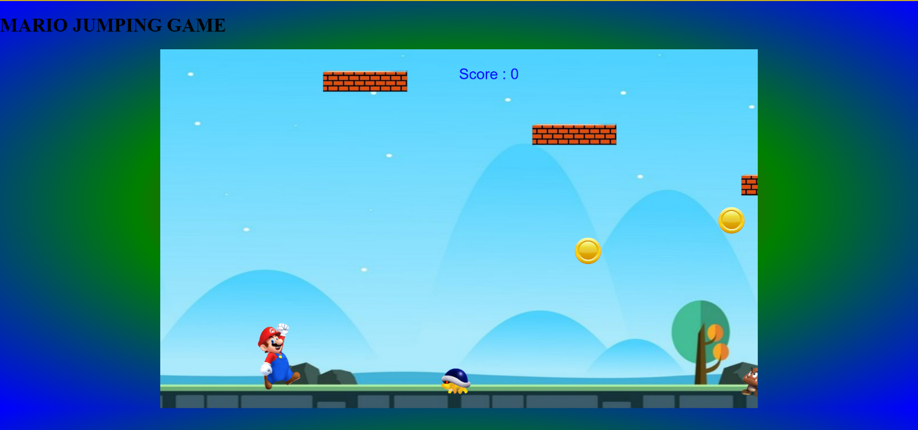**

**RESTART GAME:**

**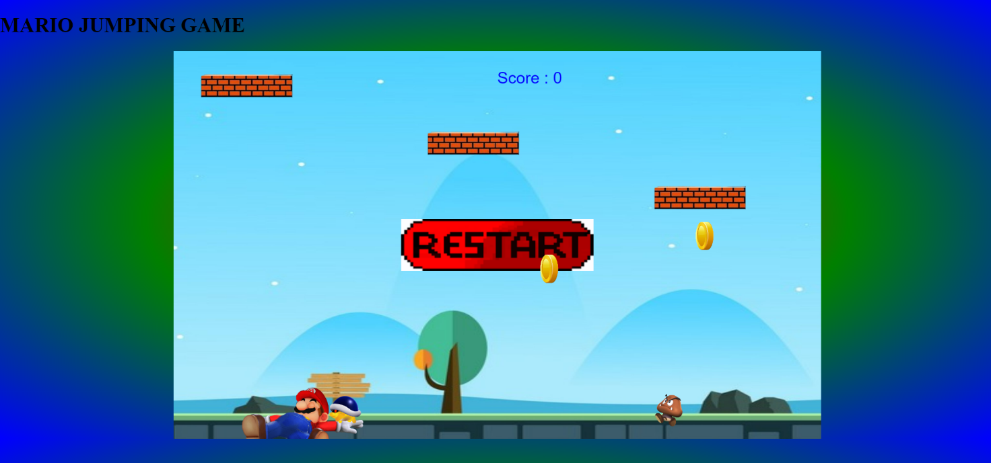**

## CONCLUSION:

Thinking of the game as a part of a bigger educational process is really in the courses mindset that this project more to prompt .This game is made with the famous technology is HTML, CSS ,JAVASCRIPT.

Games can do many thing very well but they certainly can not do every thing at onces.

# REFERENCES:

* **Websites:**

• [www.w3schools.com](http://www.w3schools.com)

• <https://www.geeksforgeeks.org/>

• [www.beta-labs.in](http://www.beta-labs.in)

• **Faculty Guidelines:**

• Mr. Vikas Kumar (Technical Trainer in GLA University)

•  **GitHub Repository link:**

https://github.com/AmanKumar7878/marioGame